- Purpose:
This protocol documents the design of Eyas Endoscope (Project NO.:RR191101B) meets the requirements of IEC60601-1 / IEC 60601-2-18 standards and is compatible with Advantech (AIM-58) tablet.

- Scope/History Background:
- This protocol is based on the IEC60601-1 / IEC 60601-2-18 standards.
- This protocol applies to Eyas Endoscope 0°(RE401SE1) and Eyas Endoscope 30°(RE921SE1).
- The structure and specification are similar between Eyas Endoscope 0°(RE401SE1) and Eyas Endoscope 30°(RE921SE1). The tube size is smaller and more components in Eyas Endoscope 0°(RE401SE1) . So this verification select Eyas Endoscope 0°(RE401SE1) become test sample.
Item | Catalog No. | ND P/N | Product Description
1 | RE2000-01 | RE401SE1 | Eyas Endoscope 0°
2 | RE2930-01 | RE921SE1 | Eyas Endoscope 30°

- Responsibility:
  - Sample Manufacturing and Assembly: R & D Engineer.
  - Quality Inspection: Quality Engineer.
  - Quality Assurance: R & D Engineer and Quality Engineer.
  - Operators executing this protocol must have documented records showing proper training on applicable processes, tooling and equipment.

- Equipment & Material used:
  - Material
    - Because testing can be destructive, testing will be conducted according to the table listed in Item 4.2.
    - Tests shall be conducted in the sequence shown in Section 5 and refer to attachment I (the DV test flow chart).
    - Prepare the samples as described below before testing:
      - All samples should be sterilized for EO two cycles.

  - Sample Size
Group | Q'ty | P/N | Description
A | 22 | RE401SE1 | Eyas Endoscope 0°
B | 22 | RE921SE1 | Eyas Endoscope 30°
C | 1 | RE401SE1 | Eyas Endoscope 0°

A sample size of 22 pieces is required to determine process capability for critical dimensions. A sample of 22 is chosen because it represents repeatability product specifications. A size of 22 pieces is statistically significant to perform inferential statistics about the population and allows for an adequate analysis of the risk associated with the product capability (manufacturing process).

  - Equipment and Fixtures
    - Equipment
      - Test chart plant rotator with motor
      - Test chart (White/Red/Green/Blue/SFR)
      - 30° slant base holder
      - 0° base holder
      - Photometer
      - Computer with ND’s own test software
      - Digital Force Gauge Tester
      - Digital Multimeter
      - Electronic pull machine
      - Automatic load testing machine
      - Anchorage Tester
      - LCR meter
      - Projector
      - leak tester (PS-320) Sealing Fixture

    - Fixtures
      - Grip Fixture
      - Holding Fixture
      - Continuity Resistance Fixture
      - Sealing Fixture

    - Others
      - 0.26 kg weight
      - 10 pound weight
      - 0.20 kg weight
      - Hawkeye Arthroscopy Control Unit

- Process Methodology:
  - Test item summary shown in table below (For detailed test items refer 5.2 to 5.27):
Item | Inspection Item | Description | Acceptance Criteria | Test Samples | Test  Group
 |  |  |  | (Each group) | Test  Group
5.2 | Visual Inspection | Inspect for workmanship and cleanness, including flash, rough surfaces, foreign material and discoloration. | No flash, rough surfaces, foreign material and discoloration | 22 PCS | A, B
5.3 | Functional Test | The buttons response to function are workable, no failure reaction. | Device can be activated | 22 PCS | A, B
5.4 | Activation Force | Activate both switches for 10 times and measure the maximum activation force for both. | 150 to 350 gf | 22 PCS | A
5.5 | Continuity Resistance | Measure the resistance through the full length | < 0.5 ohm | 22 PCS | A
5.6 | EEprom Function | Connected to the tablet and simulating the read function | Can be read acceptable | 22 PCS | A, B
5.7 | Luminance Intensity | And insert the tip side into the light intensity meter | >2 lm | 22 PCS | A, B
5.8.1 | Sensitivity | Maximum of lighting condition and 33ms exposure time & 1XGain | Avg >150 DN | 22 PCS | A, B
5.8.2 | White Balance | Adjust R/G/B gain to be equal, to check if the R,G,B value is the same | < 15% | 22 PCS | A, B
5.8.3 | SFR Test | Specific SFR formula (calculate the B/W boundary) | 0.35 < Value < 1 @1/2NY | 22 PCS | A, B
5.8.4 | Uniformity Test | AVG[Up/Down/Left/Right]  divided AVG[Center] | >50% | 22 PCS | A, B
5.8.5 | Color Response Test | Count the mean of R/G/B value, and check if the value is under the SPEC | 0.9<R/G<1.4  0.8<B/G<1.4 | 22 PCS | A, B
5.8.6 | Dust/Spot Test | Each pixel compare to neighbor 7*7 block | <10% @ center  <80% @edge area | 22 PCS | A, B
5.8.7 | Dark Test | Check the mean of dark level | Avg <20DN | 22 PCS | A, B
5.8.8 | Noise Test | Standard division of one image.  Standard division of two frames difference in each pixel | STDEV<6 | 22 PCS | A, B
5.8.9 | Stray Light Test | Check the average level of night block | Each block mean <30 | 22 PCS | A, B
5.9 | Activation Over Time | The buttons response to function are workable, no failure reaction. | Device can be activated | 22 PCS | A, B
5.10 | Leakage Test | The pressure without any leak on the camera tube. | The pressure must not drop by more than 5%. | 22 PCS | A, B
5.11 | Camera Tube Wobble | Push the Camera Tube | < 5 degree | 22 PCS | A, B
5.12 | Fluid Ingress Test | Steadily pour one liter of 0.9% saline solution from 360 degree angle back and forth the devices for 10 minutes to wet the entire length of the handle | Device can be activated | 1 PCS | C
5.13 | Plug Insertion & Extraction Force | Samples insert and extract plug from a test fixture equivalent to connector of console box | 1~3 kgf | 22 PCS | A
5.14 | 0.26kg Dynamic Strain Relief | Test cable plug end and handpiece end in each of three axes | < 0.5 ohm | 22 PCS | A
5.15 | 10 LBF Static Strain Relief | Test cable plug end and handpiece end in each of three axes | < 0.5 ohm | 22 PCS | A
5.16 | Weld Integrity Test | Using a Force gauge tester; stress the body perpendicular from the axis of the weld at the tail of the handpiece body. | >10 lbf | 22 PCS | A, B

  - Visual Inspection, Sample Group：A and B
Description:
- Inspect workmanship and cleanness, including flash, rough surfaces, foreign material and discoloration.
- Inspect the position of capture and light adjustment are correct.
Acceptance criteria:
- No flash, rough surfaces, foreign material and discoloration

  - Functional Test, Sample Group：A and B
Description:
- Ins The product should activate the proper function of Eyas endoscope when activating the capture and light adjustment button
- Click the button to check if all the function is workable
1. Luminance up/down (5step)
2. Capturing
3. Recording
Acceptance criteria:
- The active handle can properly activate the selective capture and light adjustment function.
- The buttons response to function are workable, no failure reaction.

  - Activation Force, Sample Group：A
Description:
- Activate both capture and light adjustment switches for 10 times and measure the maximum activation force for both.
- There should be a tactile response at closure.
Acceptance Criteria:
- Maximum force shall be 150 to 350 grams.

  - Continuity Resistance, Sample Group：A
Description:
- Connect one lead of Digital millimeters (in Ohm mode) to the camera tube. Connect the other lead to the ground pin of the cable connector.
- Measure the resistance through the full length.
- The test data can be accepted and recorded only when the fluctuation of the measured value is within 0.5 ohm. Record the results.
Acceptance Criteria:
- The resistance must not exceed 0.5 ohm and the fluctuation of the measured value is within 0.01 ohm.

  - EEprom Function, Sample Group：A and B
Description:
- Endoscope is writing the S/N and image setting parameter into the EEprom when execute image test software.
- Connected to the tablet and simulating the read function to make sure all the registers are usable.
Acceptance criteria:
- All main EEprom register is read/write acceptable.

  - Luminance Intensity, Sample Group：A and B
Description:
- Click the button to maximum the LED driving current. And insert the tip side into the light intensity meter
Acceptance criteria:
- Check if the luminous flux is over 2 lm.

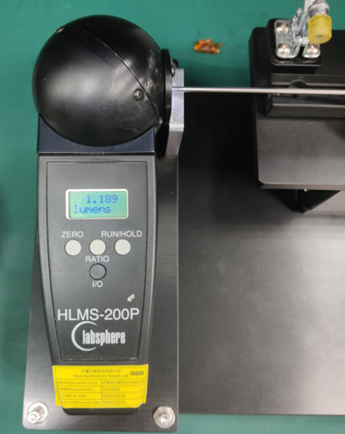

  - Image Quality Test , Sample Group：A and B
Test method：
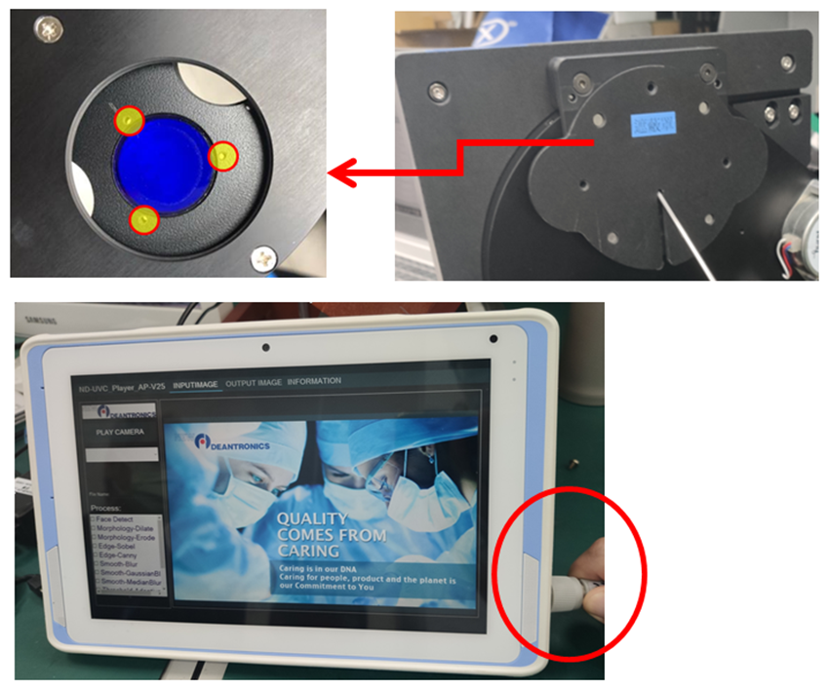
- Move the hand piece module set on the fixture and plug the circular connector to the console side. Then start the image quality test by ND’s test software.

- Checking image orientation is correct. When the hand piece is set on fixture, the image will display like below picture.
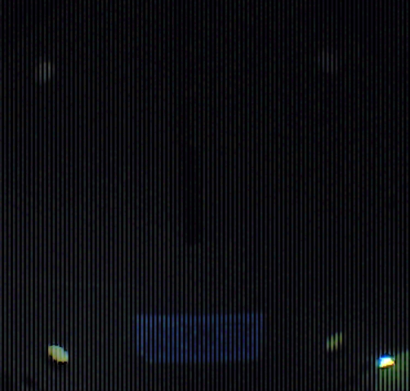

    - Sensitivity
Description:
- This test item is to check the LED light intensity and camera’s sensitivity is enough.
Acceptance criteria:
- The image brightness level should be over 150(DN).
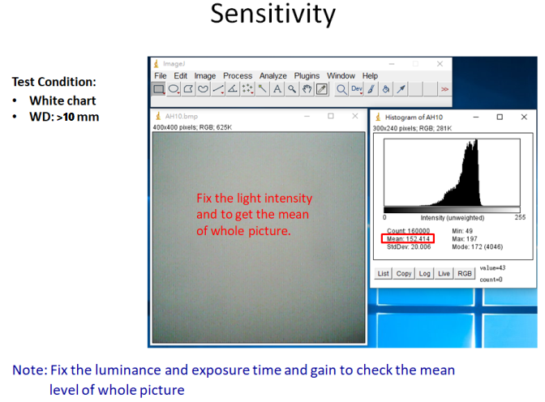

    - White Balance
Description:
- This test item is to make sure the white balance function is complete adjusted.
Acceptance criteria:
- The RGB value difference level of the white image should be under 15%.

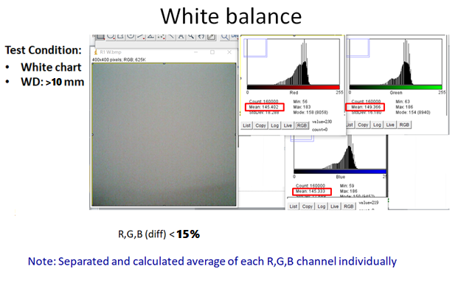

    - SFR Test
Description:
- This test item is to check MTF level (how clear could camera see).
Acceptance criteria:
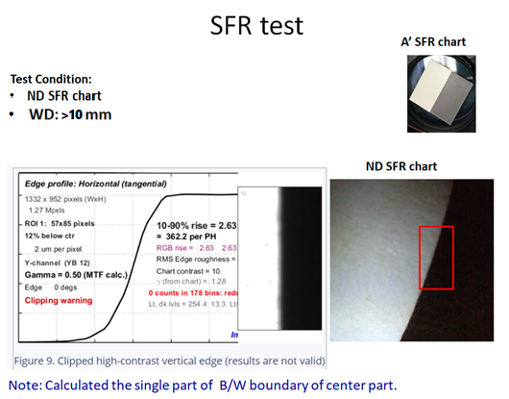
- The SFR level needs to be followed 0.35 < Value < 1.

    - Uniformity Test
Description:
- This test item is to check the lighting shape is uniform enough to see the corner.
Acceptance criteria:
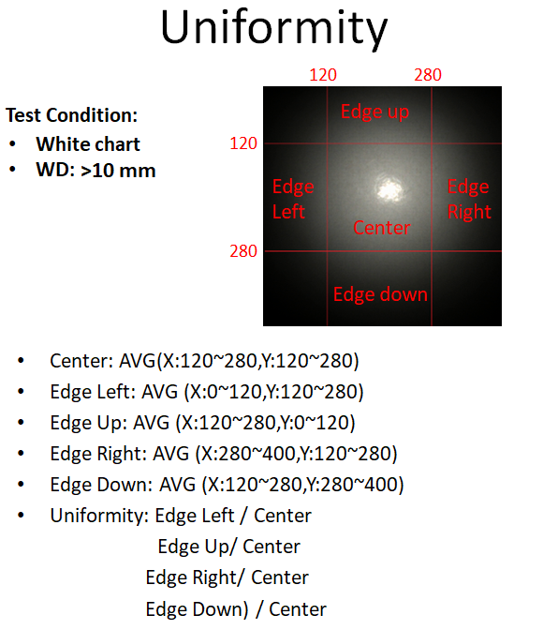
- The percentage need to be over 50%.

    - Color Response Test
Description:
- This test item is to check the color response on Red/Green/Blue chart.
Acceptance criteria:
- The difference of color ratio needs to be followed.
- 0.9 < R/G < 1.4
- 0.8 < B/G < 1. 4
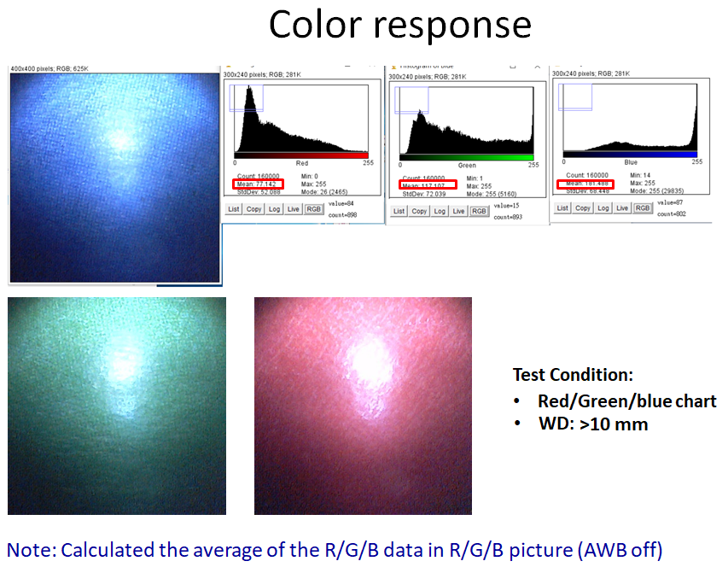

    - Dust/Spot Test
Description:
- This test item is to check there is no dust and blemish on the camera.
Acceptance criteria:
- No bad pixel on center of the image. (<10%).
- No bad pixel on edge area of the image. (<80%).

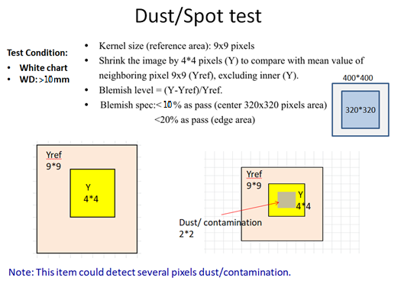

    - Dark Test
Description:
- This test item is to check the dark performance.
Acceptance criteria:
- The AVG of dark level is under 20.

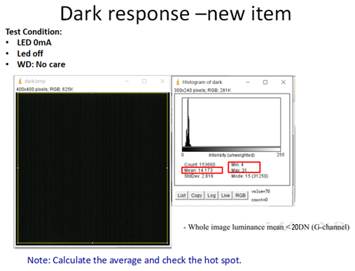

    - Noise Test
Description:
- This test item is to check the dark performance and confirm there is no critical noise in the image.
Acceptance criteria:
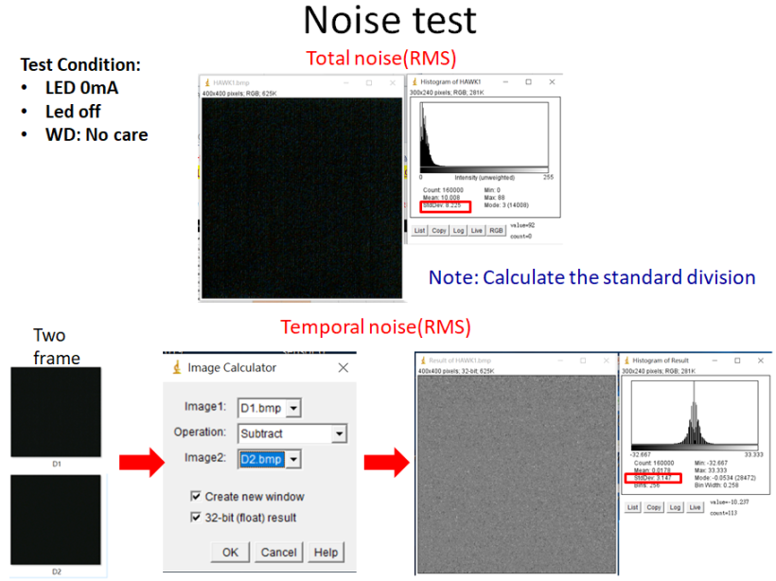
- The standard deviation of dark level is under 6.

    - Stray Light Test
Description:
- This test item is to check the dark performance with lighting.
Acceptance criteria:
- The AVG of each block is <30.
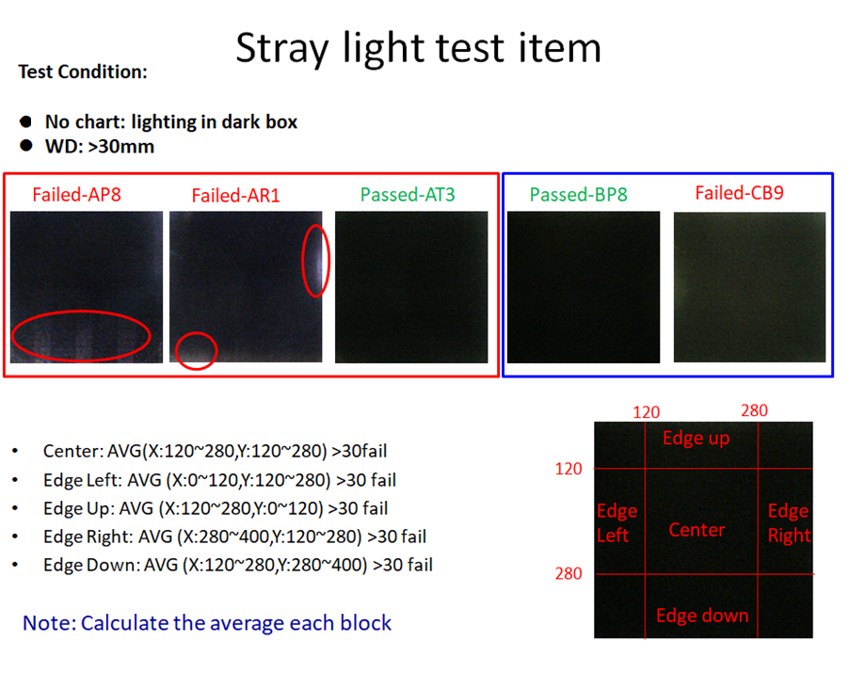

  - Activation Over Time, Sample Group：A and B
Description:
- Repeatedly cycle both capture and light adjustment switches 500 times. After all cycles are complete test if activation of the switches functions properly.
- The buttons response to function are workable, no failure reaction.
Acceptance Criteria:
- The active handle can properly activate the selective capture and light adjustment function.

  - Leakage Test, Sample Group：A and B
Description:
- Use leak tester (PS-320) and Sealing Fixture to test sealing condition of camera tube.
- Set pressure10.8 psi and hold on 30 seconds.
- Observe pressure condition and the pressure without any leak.
Acceptance criteria:
- The pressure must not drop by more than 5%.

  - Camera Tube Wobble, Sample Group：A and B
Description:
- Secure a test sample Eyas endoscope in the holding fixture.
- Use the project to measure the central line of camera tube to be center. Immediately after, using a 0.20 kg weight for camera tube.
- After each push, record the angle between the central lines of the original and new positions of the camera tube.
Acceptance criteria:
- The maximum deviation shall not exceed 5 degree.

  - Fluid Ingress Test, Sample Group：C
Description:
- Secure a test sample devices in the holding fixture with control switches facing up.
- This allows the handpiece to be at least 50 mm above the surface.
- Steadily pour one liter of 0.9% saline solution from 360 degree angle back and forth the devices for 10 minutes to wet the entire length of the handle.
- Allow the liquid to drain away freely.
Acceptance criteria:
- The function must be able to start normally.

  - Plug Insertion & Extraction Force, Sample Group：A
Description:
- Samples insert and extract plug from a test fixture equivalent to connector of console box.
Acceptance criteria:
- The maximum insertion and extraction force should be within 1 to 3 kgf.

  - 0.26kg Dynamic Strain Relief, Sample Group：A
Description:
- Test cable plug end and handpiece end in each of three axes (horizontal, vertical & handpiece axis). With plug or handpiece held firmly in place, a 0.26kg weight is attached to the cable. The weight is raised 25cm and dropped.
- A total of 3 drops are required for each sample.
- Check Functional Test per Sec. 5.3.
- Check Continuity per Sec. 5.5.
Acceptance criteria:
- The active handle can properly activate the selective capture and light adjustment function.
- The resistance must not exceed 0.5ohm.

  - 10 LBF Static Strain Relief, Sample Group：A
Description:
- Test cable plug end and handpiece end in each of three axes (horizontal, vertical & handpiece axis). With the connector or handpiece held firmly in place, a 4.6 kg (10 lbf) weight is attached to the cable.
- The weight is slowly released over 10 seconds and allowed to hang on the cable for an additional 10 seconds.
- Check Functional Test per Sec. 5.3.
- Check Continuity per Sec. 5.5.
Acceptance criteria:
- The active handle can properly activate the selective capture and light adjustment function.
- The resistance must not exceed 0.5ohm.

  - Weld Integrity Test, Sample Group：A and B
Description:
- Prior to performing this test, remove the cable/ Socorro adapter. Perform an ultrasonic weld pull test by placing the handpiece body in a vice.
- Using a Force gauge tester stress the body perpendicular from the axis of the weld at the tail of the handpiece body.
Acceptance criteria:
- The structure must withstand minimum force of 10 lbf in the camera tube end and the tail end.

- Reference Document:
  - IEC 60601-1: 2012 + AM1:2012 Edition 3.1: Medical electrical equipment - Part 1: General requirements for basic safety and essential performance.
  - IEC 60601-1-2: 2014 Edition 4.0: Medical electrical equipment –Part 1-2: General requirements for basic safety and essential performance –Collateral Standard: Electromagnetic disturbances – Requirements and tests
  - IEC 60601-2-18: 2014 Edition 3.0: Medical electrical equipment –Part 2-18: Particular requirements for the basic safety and essential performance of endoscopic equipment
  - IEC 60529: 2014 Edition 2.1: Degrees of Protection Provided by Enclosures (IP Code)
  - IEC 62304 : +AM1:2015 : Medical device software –Software life cycle processes
  - ISO 8600, Endoscopes -- Medical endoscopes and endoscopic accessories.
Part 1:2015, Part 3:1997/Amd.l:2003, Part4:2014, Part6:2005

- Data Treatment:
  - Upon completion of this protocol, a test report including raw data, CpK and discussions shall be completed.
  - This protocol should be kept at Document Control Center.
Attachment I: DV test flow chart
Date Version: 11/17/2021
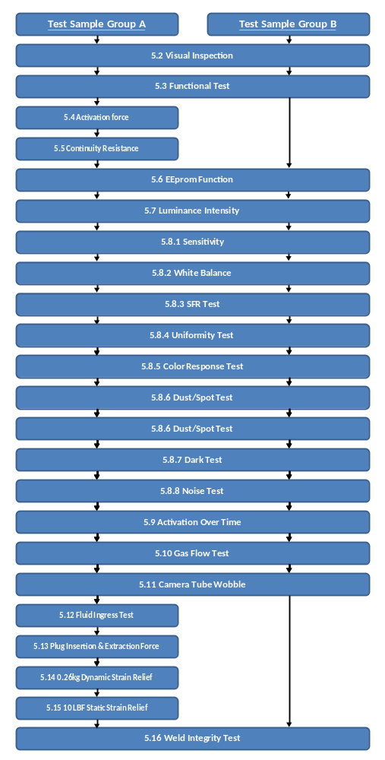
Design Verification Test Process

